**OUR REJUVENATING AFRICAN SOUL RETREAT and MAGICAL DOLPHIN SAFARI**

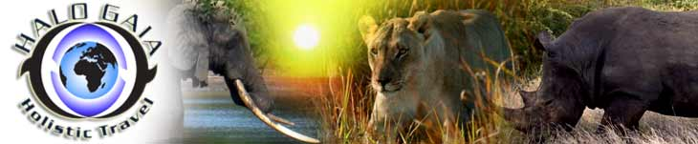

**APPLICATION FORM**

Full name      ……………………………………………………………………………………………………

Physical address      ……………………………………………………………………………………………………

                    ……………………………………………………………………………………………………

Postal address  ……………………………………………………………………………………………………

Landline              ……………………………………………………………………………………………………

Mobile             ……………………………………………………………………………………………………

Email address ……………………………………………………………………………………………………

Passport Name as shown on passport……………………………………………………….

Nationality………………………………………………………………………………….

Number….………………………………………………………………………………….

Expiry date………………………………………………………………………………….

Dietary preferences ……………………………………………………………………………………………………

Special requests    ……………………………………………………………………………………………………

Next of kin          ……………………………………………………………………………………………………

Their contact details ……………………………………………………………………………………………………

**PLEASE NOTE The non-refundable deposit is required ON REGISTRATION please. It’s US$500 for each individual retreat, but, if you are joining us for both the African Soul Retreat and Magical Dolphin Safari, it’s US$800 NON-REFUNDABLE deposit.**

**ALSO, all PayPal charges are for YOUR account! THANK YOU!**

**We are so excited to share our beloved Mama Africa with YOU!**